BooKing Manual 

**BooKing Manual Table of context.**

i.User setup

ii.Logging in

iii.Home screen

iv. New Book Entry

v. Book Search

vi. Go shop

vii. Customer order review

Viii. Employee help desk

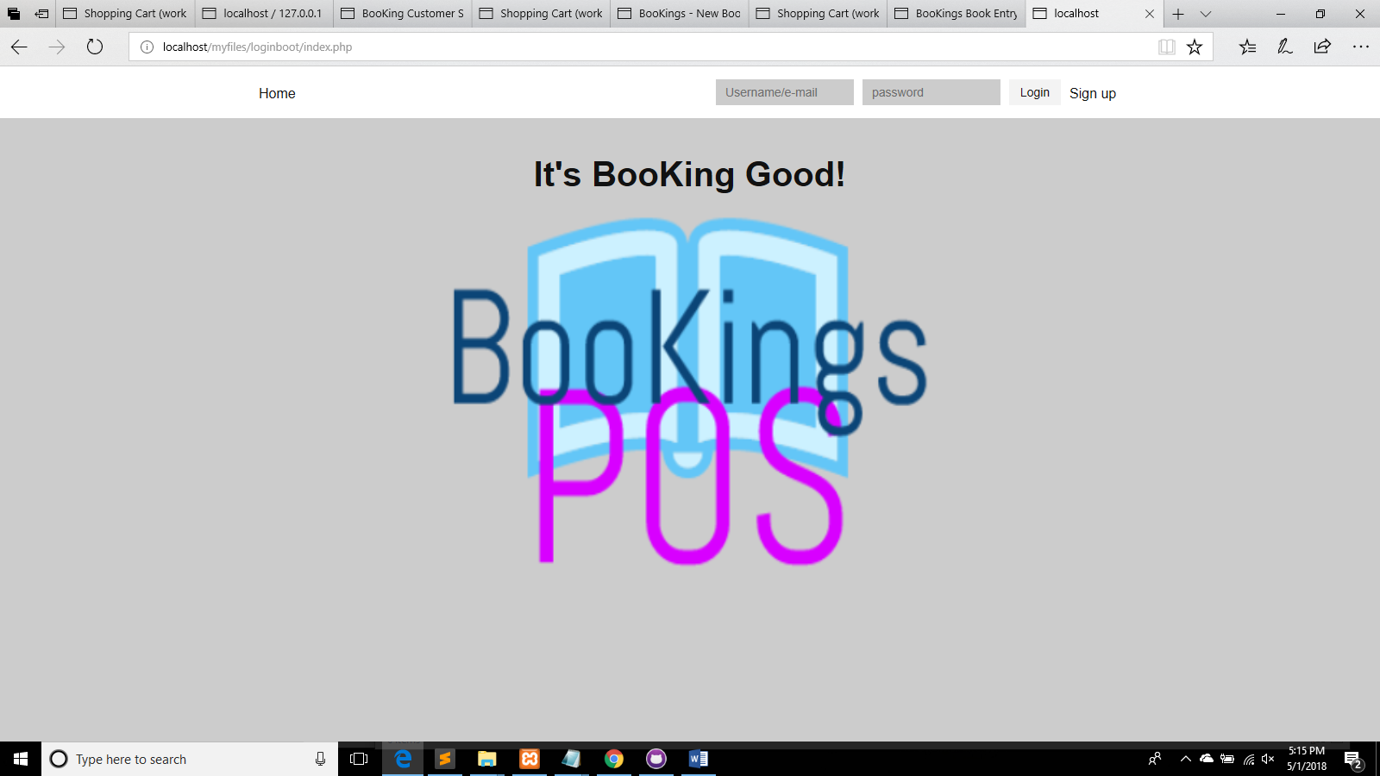

**I.User setup:**

Sign Up:

As a first-time user, you are asked to sign up using the sign up button on the top right of the screen.

After you are in the sign-up screen, please enter the correct employee information as listed.

Firstname: Please key in your first name.

Lastname: Please key in your last name,

Email: Please provide your current email address.

Username: Please provide an 8-digit user name.

Password: Please provide an 8-digit password.

Once complete, please hit “Employee signup now”.

The address bar should show “successful” if the signup is successful.

Step Review:

1. First name
2. Last name
3. Email address
4. Username
5. Password.

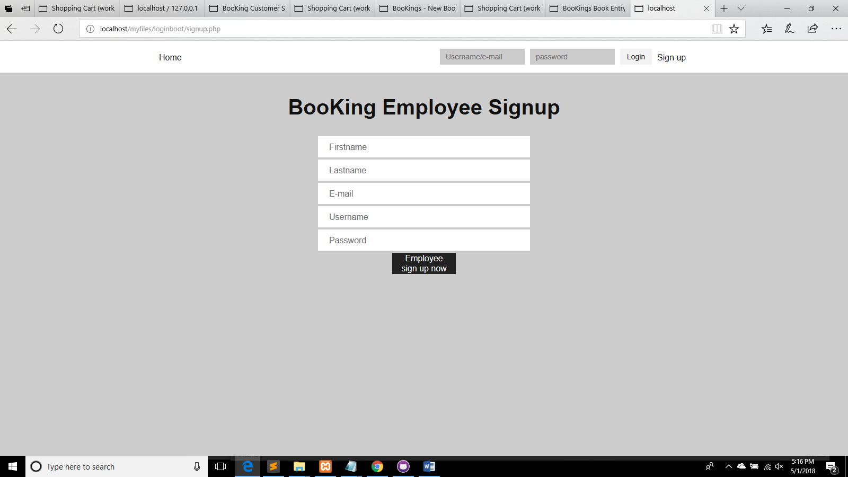

**II. Login:**

Once you have successfully signed up for a user account, you can login with your username or email and password

To do so, enter your username into the username box on the top right,

Enter your password into the password box next to the username box,

Press the “login” button. You should be directed to the “Home” page.

Steps review:

1. Username input
2. Password input
3. Press login button
4. Directed to the home screen.

**III. Home Screen**

The home screen is connected to every page and can be navigated back to by clicking on the BooKings icon.

Home screen details:

New book entry-

New search-

Customer order review-

Customer login-

Go shop-

Employee help desk-

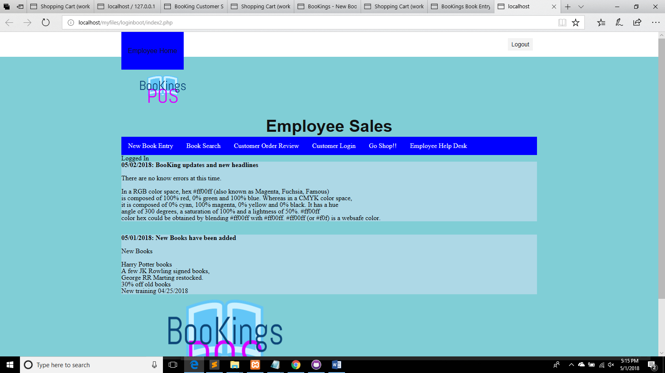

The Home screen called the “Employee Sales” Screen starts by letting the user know they are logged in.

From the main bar menu, any process can be selected and followed through.

Only from the main screen can a user log out.

**IV. New Book Entry**

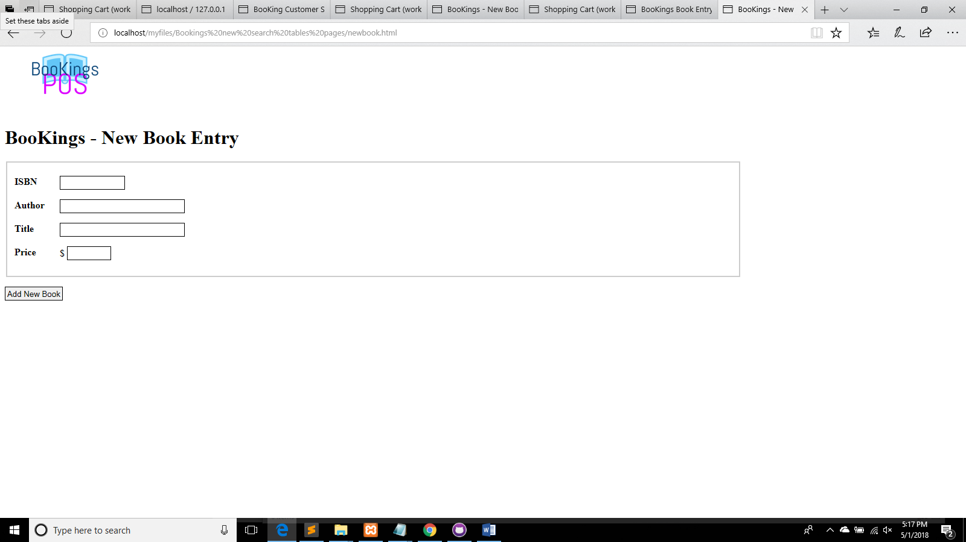

The New Book Entry tab will take you to the BooKing inventory screen where any book can be added to the database.

Please enter:

A ISBN number

An Author’s first and last name

The title of the book

And the price of the book.

Then Hit “Add New Book.”

You will then come to a page where you see “Book inserted into the database”.

You can leave the page by clicking on the icon.

**V. Book Search**

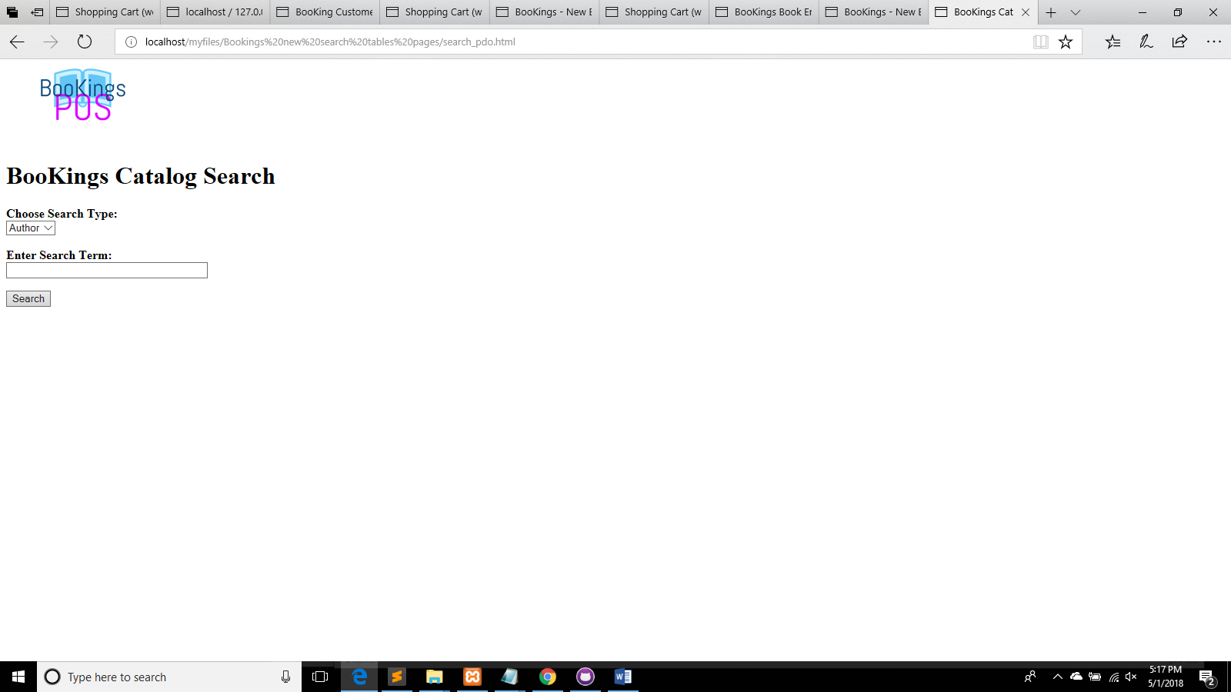

In the Book search tab, you can choose to search any book by Author, Title, Or ISBN.

Once you enter a subject press the Search function.

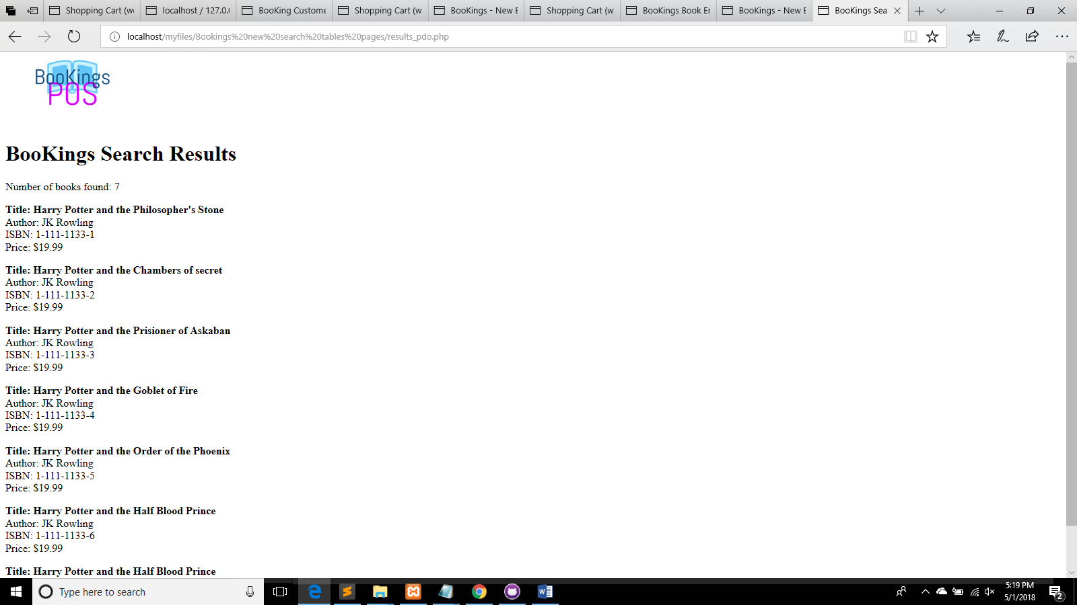

The search should show all the titles of books that compute with your search subject.

To go back to the home page, click the BooKings icon.

**VI. Go Shop**

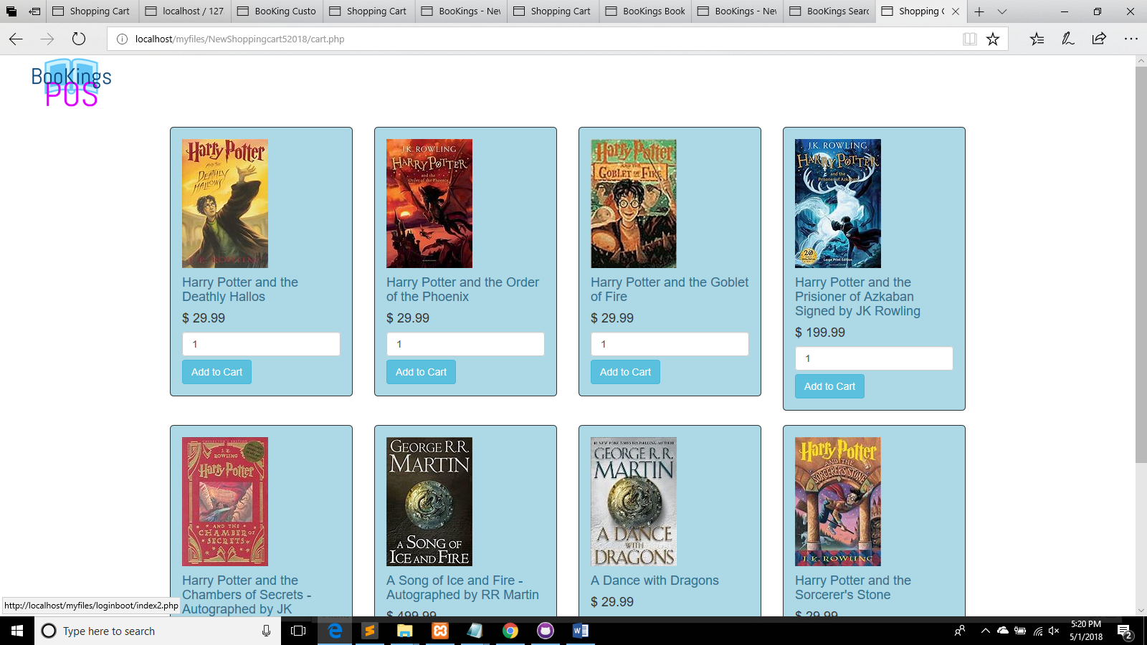

This is where every available book in stock can be shopped for. The pictures and names of the book is available along with the price.

1. Choose the book you would like
2. Read the price
3. Adjust the quantity by entering a number
4. Just press “Add to Cart”
5. At the bottom there will be a totaled price.
6. If you would like to remove the item just press “remove”
7. Then press check out to check out.
8. It will direct you to your order screen.

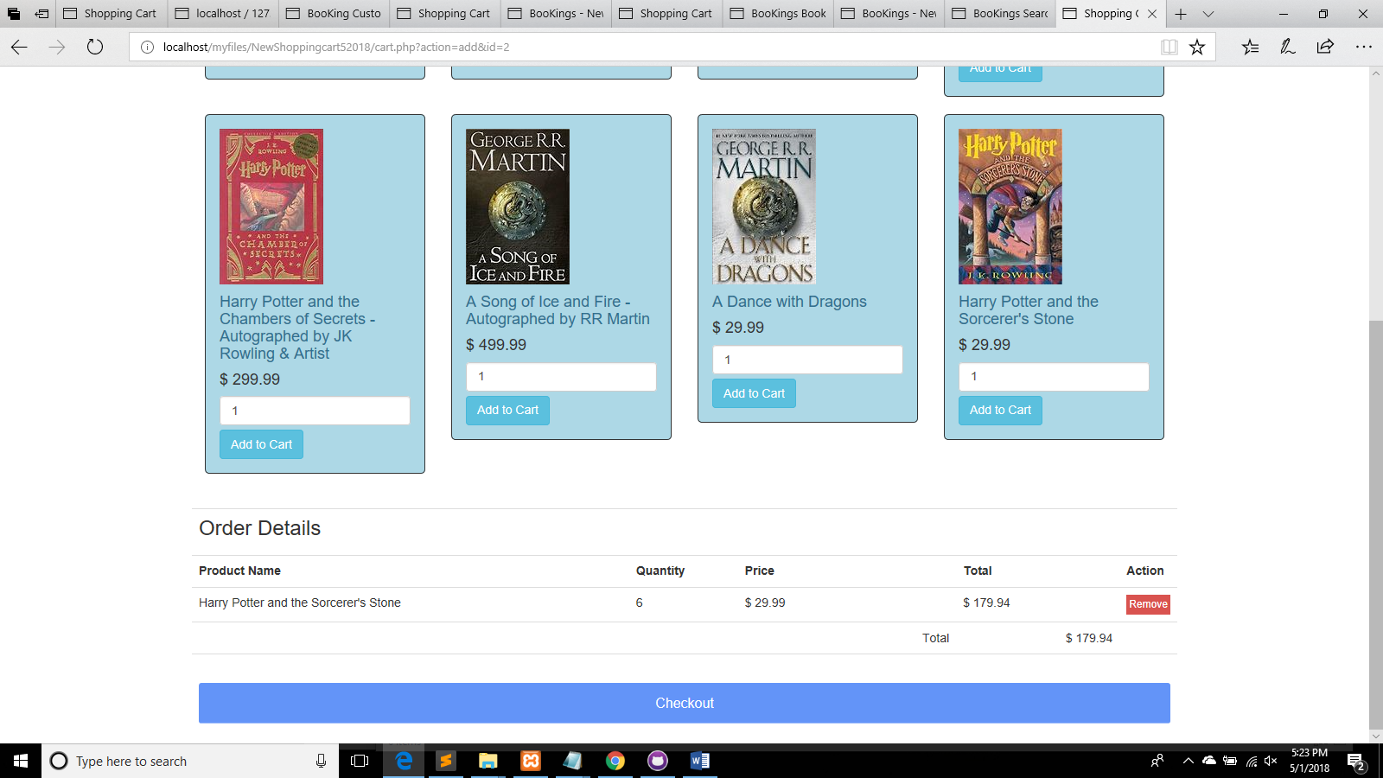

**VII. Customer Order Review**

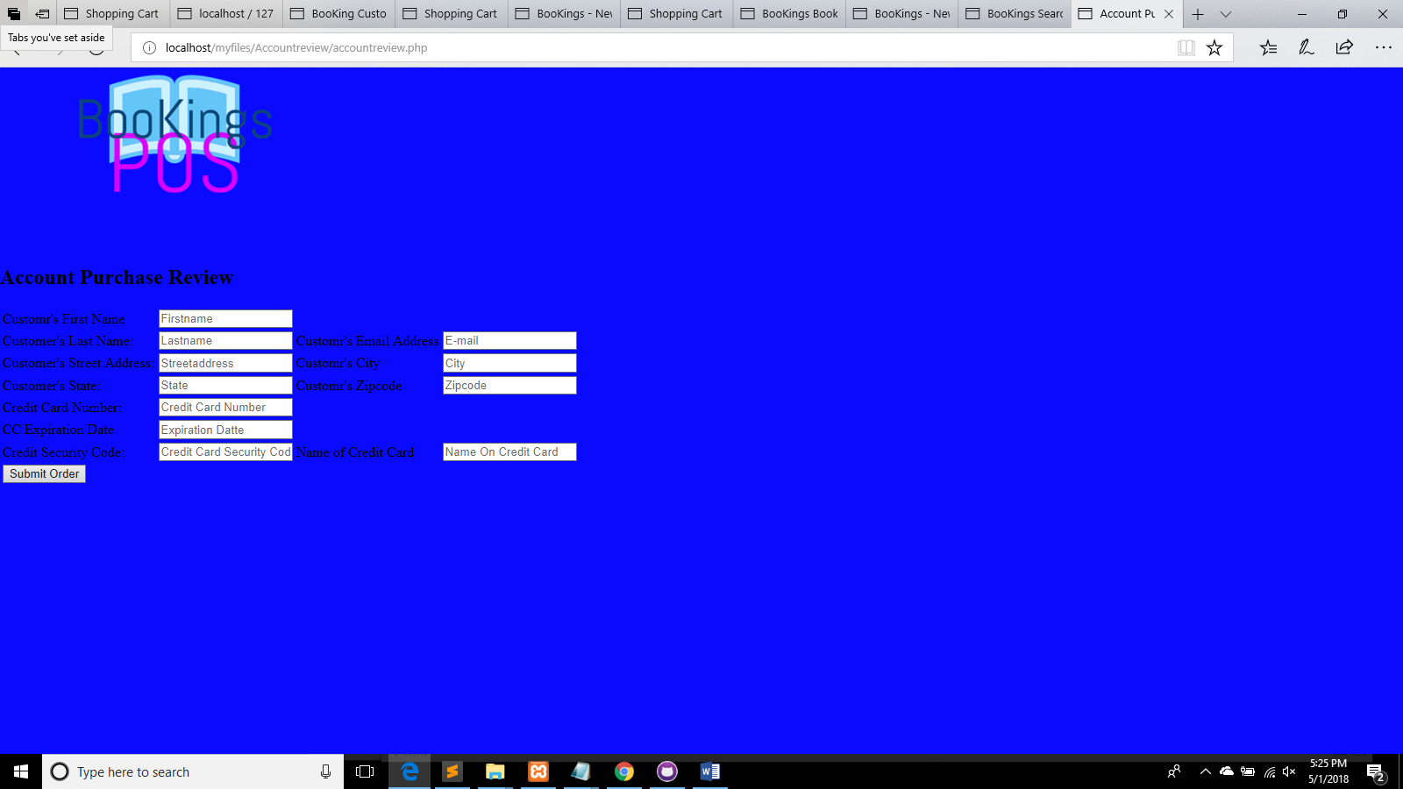

The customer order review screen is where you add your shipping information.

The credit card information.

Please input the correct information then press “submit Order”.

***Order Confirmation.***

You will receive a confirmation page stating your order is being processed.